ROMEO NXUMALO
25/SCA/BCDS/021

13. Write a program to perform tree traversal methods.
#include <stdio.h>
#include <stdlib.h>

struct Node {
int data;
struct Node* left;
struct Node* right;
};

struct Node* createNode(int value) {
struct Node* newNode = (struct Node*)malloc(sizeof(struct Node));
newNode->data = value;
newNode->left = NULL;
newNode->right = NULL;
return newNode;
}

void inorder(struct Node* root) {
if (root != NULL) {
inorder(root->left);
printf("%d ", root->data);
inorder(root->right);
}
}

void preorder(struct Node* root) {
if (root != NULL) {
printf("%d ", root->data);
preorder(root->left);
preorder(root->right);
}
}

void postorder(struct Node* root) {
if (root != NULL) {
postorder(root->left);
postorder(root->right);
printf("%d ", root->data);
}
}

int main() {

struct Node* root = createNode(1);
root->left = createNode(2);
root->right = createNode(3);
root->left->left = createNode(4);
root->left->right = createNode(5);

printf("Inorder Traversal: ");
inorder(root);

printf("\nPreorder Traversal: ");
preorder(root);

printf("\nPostorder Traversal: ");
postorder(root);

return 0;
}
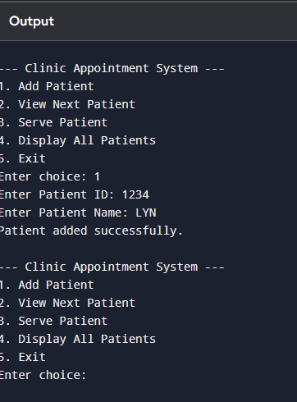

14. Write a program to perform insertion and deletion in the Binary Search Tree.
#include <stdio.h>
#include <stdlib.h>

struct Node {
int data;
struct Node *left, *right;
};

struct Node* createNode(int value) {
struct Node* newNode = (struct Node*)malloc(sizeof(struct Node));
newNode->data = value;
newNode->left = newNode->right = NULL;
return newNode;
}

struct Node* insert(struct Node* root, int value) {
if (root == NULL)
return createNode(value);

if (value < root->data)
root->left = insert(root->left, value);
else if (value > root->data)
root->right = insert(root->right, value);

return root;
}

struct Node* findMin(struct Node* root) {
while (root->left != NULL)
root = root->left;
return root;
}

struct Node* deleteNode(struct Node* root, int value) {
if (root == NULL)
return root;

if (value < root->data)
root->left = deleteNode(root->left, value);
else if (value > root->data)
root->right = deleteNode(root->right, value);
else {

if (root->left == NULL && root->right == NULL) {
free(root);
return NULL;
}

else if (root->left == NULL) {
struct Node* temp = root->right;
free(root);
return temp;
}
else if (root->right == NULL) {
struct Node* temp = root->left;
free(root);
return temp;
}

struct Node* temp = findMin(root->right);
root->data = temp->data;
root->right = deleteNode(root->right, temp->data);
}
return root;
}

void inorder(struct Node* root) {
if (root != NULL) {
inorder(root->left);
printf("%d ", root->data);
inorder(root->right);
}
}

int main() {
struct Node* root = NULL;

root = insert(root, 50);
insert(root, 30);
insert(root, 70);
insert(root, 20);
insert(root, 40);
insert(root, 60);
insert(root, 80);

printf("Inorder before deletion: ");
inorder(root);

root = deleteNode(root, 50);

printf("\nInorder after deletion of 50: ");
inorder(root);

return 0;
}
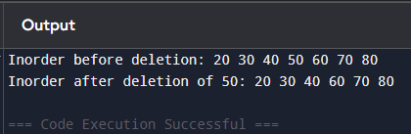

15. Write a program to represent an undirected graph using the adjacency matrix to implement the graph and perform the operations with menu-driven options for the following tasks: 1. Create graph 2. Insert an edge 3. Print Adjacency Matrix 4. List all vertices that are adjacent to a specified vertex. 6. Exit program
#include <stdio.h>

#define MAX 10

int adj[MAX][MAX];
int n;

void createGraph() {
int i, j;
printf("Enter number of vertices: ");
scanf("%d", &n);

for (i = 0; i < n; i++) {
for (j = 0; j < n; j++) {
adj[i][j] = 0;
}
}
printf("Graph created with %d vertices.\n", n);
}

void insertEdge() {
int u, v;

printf("Enter edge (u v): ");
scanf("%d %d", &u, &v);

if (u >= n || v >= n || u < 0 || v < 0) {
printf("Invalid vertices!\n");
return;
}

adj[u][v] = 1;
adj[v][u] = 1;

printf("Edge inserted between %d and %d.\n", u, v);
}

void printMatrix() {
int i, j;

printf("Adjacency Matrix:\n");
for (i = 0; i < n; i++) {
for (j = 0; j < n; j++) {
printf("%d ", adj[i][j]);
}
printf("\n");
}
}

void adjacentVertices() {
int v, i;
printf("Enter vertex: ");
scanf("%d", &v);

if (v >= n || v < 0) {
printf("Invalid vertex!\n");
return;
}

printf("Vertices adjacent to %d: ", v);
for (i = 0; i < n; i++) {
if (adj[v][i] == 1) {
printf("%d ", i);
}
}
printf("\n");
}

int main() {
int choice;

while (1) {
printf("\n--- Graph Menu ---\n");
printf("1. Create Graph\n");
printf("2. Insert Edge\n");
printf("3. Print Adjacency Matrix\n");
printf("4. List Adjacent Vertices\n");
printf("5. Exit\n");
printf("Enter your choice: ");
scanf("%d", &choice);

switch (choice) {
case 1:
createGraph();
break;
case 2:
insertEdge();
break;
case 3:
printMatrix();
break;
case 4:
adjacentVertices();
break;
case 5:
return 0;
default:
printf("Invalid choice!\n");
}
}

return 0;
}
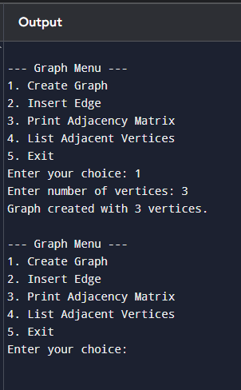

16. Kalnirnay: Conversion from Gregorian to Hindi calendar.
#include <stdio.h>

void getHindiMonth(int day, int month) {

switch(month) {
case 1:
if(day < 14) printf("Paush");
else printf("Magh");
break;
case 2:
if(day < 13) printf("Magh");
else printf("Phalgun");
break;
case 3:
if(day < 15) printf("Phalgun");
else printf("Chaitra");
break;
case 4:
if(day < 14) printf("Chaitra");
else printf("Vaishakh");
break;
case 5:
if(day < 15) printf("Vaishakh");
else printf("Jyeshtha");
break;
case 6:
if(day < 15) printf("Jyeshtha");
else printf("Ashadha");
break;
case 7:
if(day < 16) printf("Ashadha");
else printf("Shravana");
break;
case 8:
if(day < 16) printf("Shravana");
else printf("Bhadrapada");
break;
case 9:
if(day < 16) printf("Bhadrapada");
else printf("Ashwin");
break;
case 10:
if(day < 16) printf("Ashwin");
else printf("Kartika");
break;
case 11:
if(day < 15) printf("Kartika");
else printf("Margashirsha");
break;
case 12:
if(day < 14) printf("Margashirsha");
else printf("Paush");
break;
default:
printf("Invalid");
}
}

int main() {
int day, month, year;
int vikramSamvat;

printf("Enter Gregorian Date (DD MM YYYY): ");
scanf("%d %d %d", &day, &month, &year);

if (month >= 4)
vikramSamvat = year + 57;
else
vikramSamvat = year + 56;

printf("\nApprox Hindi Calendar Date:\n");
printf("Day: %d\n", day);
printf("Month: ");
getHindiMonth(day, month);
printf("\nYear (Vikram Samvat): %d\n", vikramSamvat);

return 0;
}
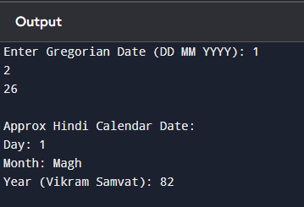

17. Create a basic system that recommends irrigation time based on soil type and crop, using linked lists to store crop data.
#include <stdio.h>
#include <stdlib.h>
#include <string.h>

struct Crop {
char name[30];
char soil[20];
int waterTime;
struct Crop* next;
};

struct Crop* head = NULL;

void addCrop(char name[], char soil[], int time) {
struct Crop* newNode = (struct Crop*)malloc(sizeof(struct Crop));
strcpy(newNode->name, name);
strcpy(newNode->soil, soil);
newNode->waterTime = time;
newNode->next = head;
head = newNode;
}

void displayCrops() {
struct Crop* temp = head;
printf("\nAvailable Crop Data:\n");
while (temp != NULL) {
printf("Crop: %s | Soil: %s | Irrigation Time: %d mins\n",
temp->name, temp->soil, temp->waterTime);
temp = temp->next;
}
}

void recommendIrrigation(char cropName[], char soilType[]) {
struct Crop* temp = head;
int found = 0;

while (temp != NULL) {
if (strcmp(temp->name, cropName) == 0 &&
strcmp(temp->soil, soilType) == 0) {
printf("\nRecommended irrigation time for %s in %s soil: %d minutes\n",
cropName, soilType, temp->waterTime);
found = 1;
break;
}
temp = temp->next;
}

if (!found) {
printf("\nNo exact match found. Try different crop/soil combination.\n");
}
}

int main() {
int choice;
char crop[30], soil[20];
int time;

addCrop("Wheat", "Loamy", 30);
addCrop("Rice", "Clay", 60);
addCrop("Cotton", "Black", 45);
addCrop("Maize", "Sandy", 25);

while (1) {
printf("\n--- Irrigation System Menu ---\n");
printf("1. Add Crop Data\n");
printf("2. Display Crops\n");
printf("3. Recommend Irrigation\n");
printf("4. Exit\n");
printf("Enter choice: ");
scanf("%d", &choice);

switch (choice) {
case 1:
printf("Enter Crop Name: ");
scanf("%s", crop);
printf("Enter Soil Type: ");
scanf("%s", soil);
printf("Enter Irrigation Time (minutes): ");
scanf("%d", &time);
addCrop(crop, soil, time);
break;

case 2:
displayCrops();
break;

case 3:
printf("Enter Crop Name: ");
scanf("%s", crop);
printf("Enter Soil Type: ");
scanf("%s", soil);
recommendIrrigation(crop, soil);
break;

case 4:
exit(0);

default:
printf("Invalid choice!\n");
}
}

return 0;
}
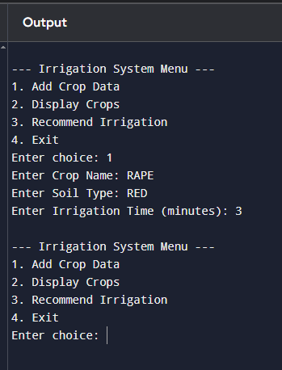
18. Design and implement a queue-based appointment management system for a clinic that handles patients in the order of their arrival. The system should maintain a First-Come, First- Served (FCFS) queue for patients and provide options to add new patients, view the next patient to be treated, serve (remove) a patient once treated, and display the list of all waiting patients.
#include <stdio.h>
#include <stdlib.h>
#include <string.h>

struct Patient {
int id;
char name[50];
struct Patient* next;
};

struct Patient *front = NULL, *rear = NULL;

void addPatient(int id, char name[]) {
struct Patient* newNode = (struct Patient*)malloc(sizeof(struct Patient));
newNode->id = id;
strcpy(newNode->name, name);
newNode->next = NULL;

if (rear == NULL) {
front = rear = newNode;
} else {
rear->next = newNode;
rear = newNode;
}

printf("Patient added successfully.\n");
}

void viewNextPatient() {
if (front == NULL) {
printf("No patients in queue.\n");
} else {
printf("Next patient: ID=%d, Name=%s\n", front->id, front->name);
}
}

void servePatient() {
if (front == NULL) {
printf("No patients to serve.\n");
return;
}

struct Patient* temp = front;
printf("Serving patient: ID=%d, Name=%s\n", temp->id, temp->name);

front = front->next;
if (front == NULL)
rear = NULL;

free(temp);
}

void displayPatients() {
if (front == NULL) {
printf("No patients waiting.\n");
return;
}

struct Patient* temp = front;
printf("\nWaiting Patients:\n");
while (temp != NULL) {
printf("ID=%d, Name=%s\n", temp->id, temp->name);
temp = temp->next;
}
}

int main() {
int choice, id;
char name[50];

while (1) {
printf("\n--- Clinic Appointment System ---\n");
printf("1. Add Patient\n");
printf("2. View Next Patient\n");
printf("3. Serve Patient\n");
printf("4. Display All Patients\n");
printf("5. Exit\n");
printf("Enter choice: ");
scanf("%d", &choice);

switch (choice) {
case 1:
printf("Enter Patient ID: ");
scanf("%d", &id);
printf("Enter Patient Name: ");
scanf("%s", name);
addPatient(id, name);
break;

case 2:
viewNextPatient();
break;

case 3:
servePatient();
break;

case 4:
displayPatients();
break;

case 5:
exit(0);

default:
printf("Invalid choice!\n");
}
}

return 0;
}
